**Theme 9. Example in R**

**Exercise 1.**

1. **Define the type of the variables**

**Because the variables have infinite values spectra then they’re the numeric type.**

1. **Prepare the data to get into R. Watch the video how to import data in Google Sheet -** <https://youtu.be/sy-j-sqd0t8>

After the data has been successfully imported use commands as shown below:

Input = ("Glucose level Body weight

4 70

6 72

6 90

2 80

2 102

4 92

5 94

4 81

4 78

6 84

6 100

7 90

7 93

3 83

3 81

3 72

3 69

2 72

2 68

2 120

4 108

3 97

3 82

2 93")

DF = as.data.frame(read.table(textConnection(Input), header = TRUE, sep = "\t"))

This will allow you to work with data from the single variable of type data.frame. To access specific variable in the data.frame use the $ sign. For example, to get the Glucose level one have to use DF$Glucose.level

Alternatively, one can construct data frame from the column vectors by using commands:

glucose_lvl <- c(4,6,6,2,2,4,5,4,4,6,6,7,7,3,3,3,3,2,2,2,4,3,3,2)

body_weight <- c(70,72,90,80,102,92,94,81,78,84,100,90,93,83,81,72,69,72,68,120,108,97,82,93)

DF =data.frame(Glucose.lvl = glucose_lvl, Body.weight = body_weight)

1. **Calculate mean, median, mode**

To get the **mean** one has to use command mean

mean(DF$Glucose.lvl)

Result:

> mean(DF$Glucose.lvl)

[1] 3.875

mean(DF$Body.weight)

Result:

> mean(DF$Body.weight)

[1] 86.29167

**Median** can be calculated by use of command median

median(DF$Glucose.lvl)

Result:

> median(DF$Glucose.lvl)

[1] 3.5

median(DF$Glucose.lvl)

Result:

> median(DF$Body.weight)

[1] 83.5

**Mode** can be obtained in two ways: through the table command or via the use of Mode command from the DescTools library

table(DF$Glucose.lvl)

Result:

> table(DF$Glucose.lvl)

2 3 4 5 6 7

6 6 5 1 4 2

As one can see there are two values that has the max frequency of 6 which means variable Glucose level has 2 modes: 2, 3.

library(DescTools) # This command can be executed only once to get  
# the needed functions

Mode(DF$Glucose.lvl)

Result:

> library(DescTools)

> Mode(DF$Glucose.lvl)

[1] 2 3

attr(,"freq")

[1] 6

As you can see we’ve got the same result with a different function. It’s up to the reader (you) to obtain the mode(s) for the Body weight variable.

1. **Calculate range, standard deviation, variance, standard error of mean, standard error of median**

To get range one has to subtract the minimum value (min) of a variable from its maximum value (max).

max(DF$Glucose.lvl) - min(DF$Glucose.lvl)

Result:

> max(DF$Glucose.lvl) - min(DF$Glucose.lvl)

[1] 5

Alternatively range can be obtained via the Range function from the DescTools library.

Range(DF$Glucose.lvl)

Result:

> Range(DF$Glucose.lvl)

[1] 5

attr(,"bounds")

[1] 2 7

**Standard deviation** is being calculated through the sd function

sd(DF$Glucose.lvl)

Result:

> sd(DF$Glucose.lvl)

[1] 1.676241

sd(DF$Body.weight)

Result:

> sd(DF$Body.weight)

[1] 13.31387

**Variance** can be calculated through the var function

var(DF$Glucose.lvl)

Result:

> var(DF$Glucose.lvl)

[1] 2.809783

var(DF$Body.weight)

Result:

> var(DF$Body.weight)

[1] 177.2591

**Standard error of mean** can be obtained in two ways:

1. Manually by combining in expression the standard deviation (sd), square root (sqrt) and sample size (length) calculation functions

sd(DF$Glucose.lvl) / sqrt(length(DF$Glucose.lvl))

Result:

> sd(DF$Glucose.lvl) / sqrt(length(DF$Glucose.lvl))

[1] 0.3421612

1. Using function MeanSE from the DescTools library

DescTools::MeanSE(DF$Glucose.lvl)

Result:

> DescTools::MeanSE(DF$Glucose.lvl)

[1] 0.3421612

The way the MeanSE function being called in this example is just another way of telling R that you wish to use specific function from the specific library. But it’s not mandatory and you could safely use the short form: MeanSE(DF$Glucose.lvl) and it would still provide you with the correct result.

> MeanSE(DF$Glucose.lvl)

[1] 0.3421612

1. **Calculate confidence intervals of mean, confidence intervals of median**

**Confidence interval of mean** can be gotten in two ways:

1. From one sample t-test

t.test(DF$Body.weight)$conf.int

Result:

> t.test(DF$Body.weight)$conf.int

[1] 80.66971 91.91362

attr(,"conf.level")

[1] 0.95

Lower (or left) bound of confidence interval of mean is the first value (80.67 in this example). Upper (or right) bound of confidence interval of mean is the second value (91.91 in this example). The confidence level is 95% (0.95).

1. From MeanCI function of DescTools library

MeanCI(DF$Body.weight)

> MeanCI(DF$Body.weight)

mean lwr.ci upr.ci

86.29167 80.66971 91.91362

lwr.ci is a lower (or left) bound of the confidence interval of mean. upr.ci is an upper (or right) bound of the confidence interval of mean. The default confidence level for the MeanCI function is 0.95.

**Confidence interval of median** can be obtained by MedianCI function from DescTools library

MedianCI(DF$Glucose.lvl)

> MedianCI(DF$Glucose.lvl)

median lwr.ci upr.ci

3.5 3.0 5.0

attr(,"conf.level")

[1] 0.9773442

lwr.ci is a lower (or left) bound of the confidence interval of median. upr.ci is an upper (or right) bound of the confidence interval of median. The default confidence level for the MedianCI function is 0.95.

1. **Check if the samples follow normal distribution**

To check if the sample follows the normal distribution one has to apply the Shapiro-Wilk test. It can be done via the shapiro.test function. If the sample follows normal distribution, then the Shapiro-Wilk test will give p-value greater than the significance level of 0.05. If the opposite is true, then the sample doesn’t follow the normal distribution.

shapiro.test(DF$Glucose.lvl)

Result:

> shapiro.test(DF$Glucose.lvl)

Shapiro-Wilk normality test

data: DF$Glucose.lvl

W = 0.87708, p-value = 0.007263

As we can see Glucose level variable doesn’t follow normal distribution because it’s p-value is lower than the significance level of 0.05. We can confirm this by plotting the histogram of the Glucose level variable. To do so we have to use hist function. Result of the function is presented on figure 1.

hist(DF$Glucose.lvl, main = "Glucose level", xlab = "Value")

main = “Glucose level” – title of the histogram plot

xlab = “Value” – title of the horizontal axis

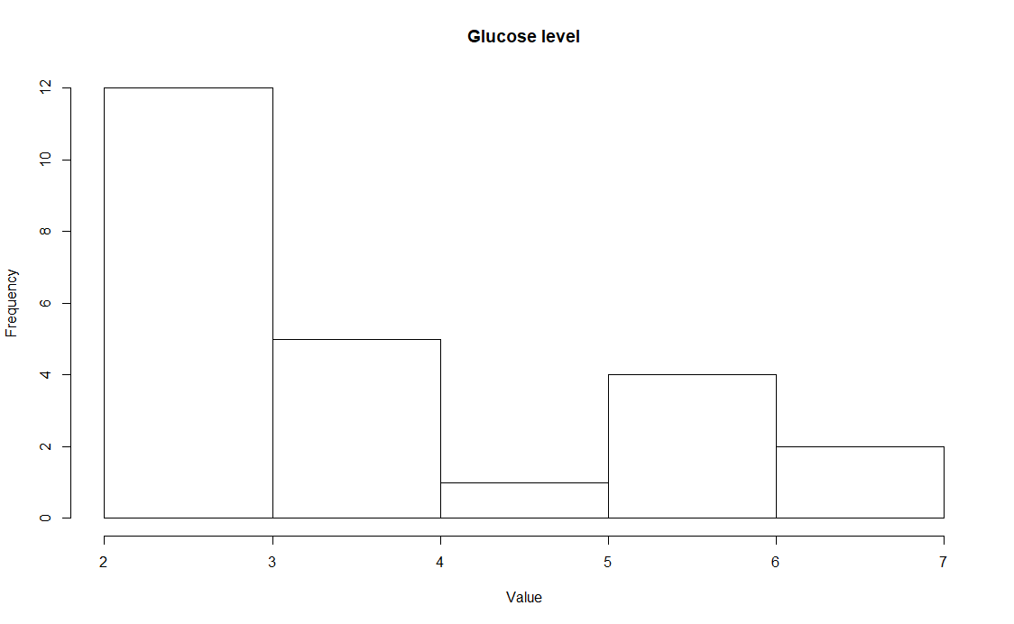

Fig.1. Histogram of the Glucose level variable. The variable frequencies are skewed towards left and hence evidence against variable being normally distributed.

For the Body weight we have the opposite case.

> shapiro.test(DF$Body.weight)

Shapiro-Wilk normality test

data: DF$Body.weight

W = 0.95007, p-value = 0.2719

As one can see the Body weight’s p-value exceeds the significance level of 0.05 which means Body weight variable follows the normal distribution. The histogram of the Body weight variable is plotted in figure 2.

hist(DF$Body.weight, main = "Body weight", xlab = "Value")

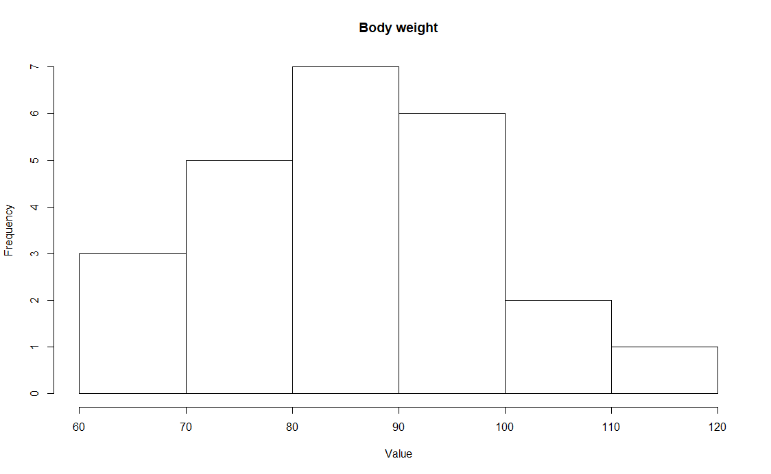

Fig.2. Histogram of Body weight variable. The variable frequencies are distributed in a bell-like pattern which is in agreement with the Shapiro-Wilk test results.

1. **Gathering the results**

We should garner the results in a table. To do so we could have stored the results in a separate variables (the preferred way) or we can produce an expression which combines all of the required functions.

R variable *gl_summary* to hold calculation results for the Glucose level:

gl_summary <- list(  
 Name = "Glucose level",  
 Size = length(DF$Glucose.lvl),   
 Min = min(DF$Glucose.lvl), Max = max(DF$Glucose.lvl),  
 Mean = mean(DF$Glucose.lvl),   
 Median = median(DF$Glucose.lvl),   
 SD = sd(DF$Glucose.lvl), Var = var(DF$Glucose.lvl),  
 SEM = DescTools::MeanSE(DF$Glucose.lvl),   
 lwr.CI = t.test(DF$Glucose.lvl)$conf.int[1],  
 upr.CI = t.test(DF$Glucose.lvl)$conf.int[2]  
)

Variable *gl_summary* is a list of pairs *tag* = *value*. *Tag* serves only as a name for the *value* and doesn’t affect calculations, but instead one can address the specific value by its tag.

R variable *bw_summary* to hold calculation results for the Body weight:

bw_summary <- list(  
 Name = "Body weight",   
 Size = length(DF$Body.weight),   
 Min = min(DF$Body.weight),

Max = max(DF$Body.weight),

Mean = mean(DF$Body.weight),

Median = median(DF$Body.weight),   
 SD = sd(DF$Body.weight), Var = var(DF$Body.weight),  
 SEM = DescTools::MeanSE(DF$Body.weight),   
 lwr.CI = t.test(DF$Body.weight)$conf.int[1],  
 upr.CI = t.test(DF$Body.weight)$conf.int[2]  
)

Final data frame to hold the calculation results is done through the merge of the above variables. During the merge process both variable can be treated either as rows or columns. To merge the variables as rows one has to use rbind function. To merge the variables as columns (preferred method) one has to use cbind function.

rbind(gl_summary,bw_summary)

Result:

> rbind(gl_summary,bw_summary)

Name Size Min Max Mean Median SD Var SEM lwr.CI upr.CI

gl_summary "Glucose level" 24 2 7 3.875 3.5 1.676241 2.809783 0.3421612 3.167186 4.582814

bw_summary "Body weight" 24 68 120 86.29167 83.5 13.31387 177.2591 2.717682 80.66971 91.91362

cbind(gl_summary,bw_summary)

Result:

> cbind(gl_summary,bw_summary)

gl_summary bw_summary

Name "Glucose level" "Body weight"

Size 24 24

Min 2 68

Max 7 120

Mean 3.875 86.29167

Median 3.5 83.5

SD 1.676241 13.31387

Var 2.809783 177.2591

SEM 0.3421612 2.717682

lwr.CI 3.167186 80.66971

upr.CI 4.582814 91.91362

Store your calculations as a data frame

DF_Summary = as.data.frame(cbind(gl_summary, bw_summary))

Now you can access the specific value by addressing it through the $ sign. For example, to get the upper CI for the Body weight one has to execute DF_Summary$bw_summary$upr.CI

**Conclusion**: Glucose level lies in range of values of [2; 7] with a 95% confidence interval of mean [3.16; 4.58] and doesn’t follow normal distribution. Median value of Glucose level is 3.875. Standard error of   
mean is almost 10 times lower of the mean value which evidences about sample being representative to the population. Body weight follows normal distribution and its values belong to the range of [68; 120] with the 95% confidence interval of mean [80.67; 91.91]. Standard error of mean for the Body weight variable is approximately 40 times lower than the mean value which points to the fact of a given sample   
being representative to its population.

**Exercise 5**

1. **Determine the variable type**

Because the variable’s value spectrum is finite it’s nominal type of data.

1. **Input the data in R.**

Prepare the data in CSV (comma-separated value) format to become a matrix Use the read.csv function

Input = ("

Case, Main Group, Control Group

Disease, 5, 9

Healthy, 155, 91"

)

Data = as.data.frame(read.csv(textConnection(Input), header = TRUE, row.names = 1))

Result:

> Input = ("

+ Case, Main Group, Control Group

+ Disease, 5, 9

+ Healthy, 155, 91")

> Data = as.data.frame(read.csv(textConnection(Input), header = TRUE, row.names = 1))

> Data

Main.Group Control.Group

Disease 5 9

Healthy 155 91

1. **Calculate the proportions**

To get the proportions for the groups in Data one has to convert Data into a matrix and use it as an argument in a prop.table function with additional argument *margin = 2*. Setting margin to 2 tells function to calculate proportions relative to the sum of columns in the source matrix which translates in cases count for each group.

Data.prop = prop.table(Data, margin = 2)

Data.prop

Result:

Data.prop

Main.Group Control.Group

Disease 0.03125 0.09

Healthy 0.96875 0.91

1. **Calculate Confidence Intervals for the proportions**

For the confidence intervals one has to perform one-sample binom.test function on each of the groups.

mg_summary = binom.test(Data$Main.Group)

Result:

> mg_summary = binom.test(Data$Main.Group)

> mg_summary

Exact binomial test

data: Data$Main.Group

number of successes = 5, number of trials = 160, p-value < 2.2e-16

alternative hypothesis: true probability of success is not equal to 0.5

95 percent confidence interval:

0.01022314 0.07141770

sample estimates:

probability of success

0.03125

cg_summary = binom.test(Data$Control.Group)

Result:

> cg_summary = binom.test(Data$Control.Group)

> cg_summary

Exact binomial test

data: Data$Control.Group

number of successes = 9, number of trials = 100, p-value < 2.2e-16

alternative hypothesis: true probability of success is not equal to 0.5

95 percent confidence interval:

0.0419836 0.1639823

sample estimates:

probability of success

0.09

1. **Gathering the results**

Let’s gather the results we’ve obtained on the previous steps in single place. We’ll construct two lists with the Proportion, lwr.CI, upr.CI values corresponding to the proportion value, lower confidence interval bound, upper confidence interval bound.

cg_summary = list(Proportion = cg_summary$estimate,   
 lwr.CI = cg_summary$conf.int[1],   
 upr.CI = cg_summary$conf.int[2])

mg_summary = list(Proportion = mg_summary$estimate,   
 lwr.CI = mg_summary$conf.int[1],   
 upr.CI = mg_summary$conf.int[2])

Final data is being constructed by column combine of both control group and main group lists via cbind function.

Data.DescrStat = as.data.frame(cbind(Control.Group = cg_summary, Main.Group = mg_summary))

Result:

> Data.DescrStat = as.data.frame(cbind(Control.Group = cg_summary, Main.Group = mg_summary))

> Data.DescrStat

Control.Group Main.Group

Proportion 0.09 0.03125

lwr.CI 0.0419836 0.01022314

upr.CI 0.1639823 0.0714177

1. **Interpreting data**

Interpretation has to be started from the proportion comparison and afterwards assess if the confidence intervals of the groups are intersecting. If they are, then the conclusion has to be formulated as a hypothesis. Otherwise one can imply the conclusion, although we would suggest to make the necessary hypotheses testing to make the calculations rigorous and robust.

As one can see the Control Group has higher proportion of the ill people than the Main Group. This evidences that taking proposed drug is beneficial for immune system to resist influenza.  
The confidence intervals (CI) for the groups are intersecting (the lower bound of CI for the Main Group is in the CI of the Control Group) which means we cannot imply our finding without formulating and testing the statistical hypotheses, but we can formulate the conclusion in a form of the medical hypothesis.

**Conclusion**: Taking drug can help prevent influenza for almost 3 times better than without it.

Note the word “can” in the conclusion – it’s one of the ways to formulate the conclusion as a hypothesis.